**Game description**

Our game requires two players, co-operatively working to sustain the body of their character which according to our theme, is a cyborg unit set in the distant future of a ruined city. In this environment, the players will find various resources to help maintain the overall utility of the cyborg. One player will control the bodily functions of the character, they will have a third person view of the cyborg and its surroundings. The other player will work from within the cyborg, their role is to place resources collected by the outside player into the correct slots. The game will need two cameras to focus on the task at hand for each player.

**Player Mechanics**

The player controlling the cyborg from the outside will collect resources scattered throughout the world. Once an object has been picked up, it will be transferred inside the cyborgs body. At this point, they player inside will have to locate the resource and apply it to a designated area inside the cyborg before the resource expires.

The player inside has a top down view of the circuit board where they locate the resources gathered by the outside player. Once they collect a resource, it will fill up the vitals bar according to the resource collected.

**Enemies**

Once the player inside has managed to collect a resource, an enemy will spawn on the outside, attempting to catch the cyborg. This enemy causes damage to the cyborgs health once it collides with the outside player.

**Critical Considerations**

* We need a type of win condition for the player.
* The rate at which player vitals decrease needs to be balanced along with respawn timers of resources found by the players.
* The scale of each level for both players.
* The type of movement mechanic for the outside player.

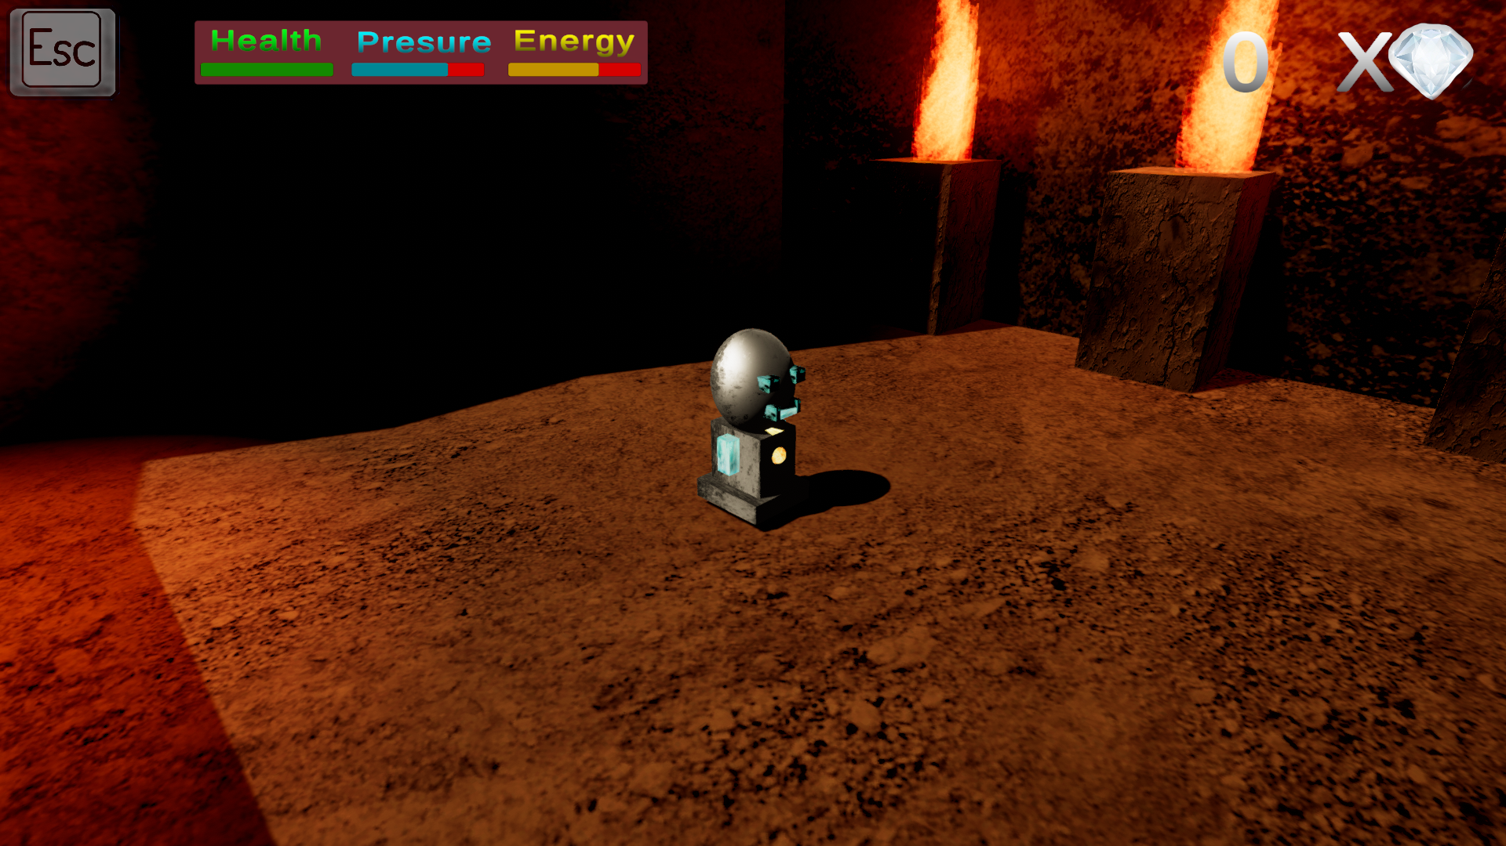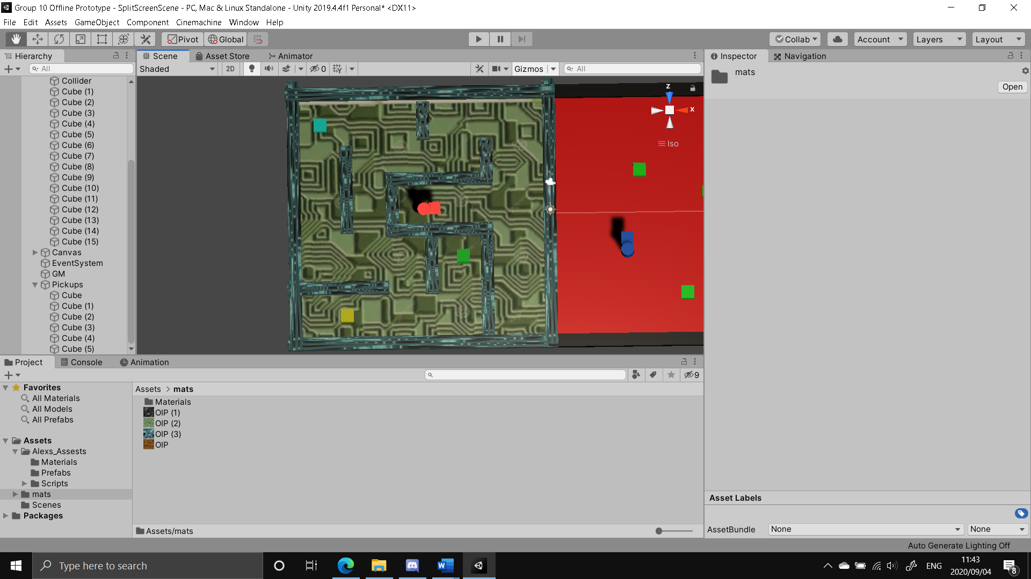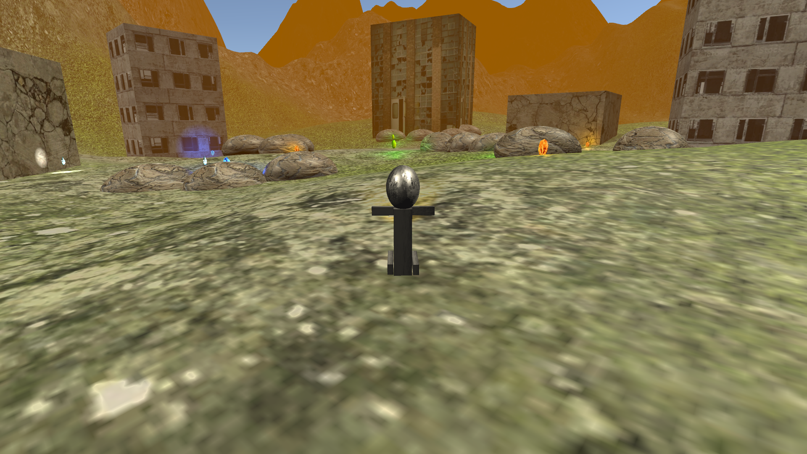

**Outside Player**

**Inside Player**